Angular Framework

Angular Framework is used to develop front end applications, it allows you to create applications which are called as client applications for variety of platforms like Mobiles, Desktops, Web and so on.

It is created by Google.

What is framework

Framework helps to build complex application easily by providing all the common features for an application inbuilt so that developers don’t have to write code for these common features, some of the common features most of the application needs are:

* Type conversion
* Internationalization
* Exception Handling

Angular Framework is a framework for front-end it uses two languages to develop the front end applications & it is used to develop single page application the two languages are:

1. HTML for displaying
2. Typescript for writing the logics

Typescript is a superset of JavaScript which is better than the Java Script

Note: Angular Framework uses CSS for styling

Single Page Application:

Single Page Applications will have one single page where you can perform all the tasks, it loads only part of the page when any action is performed and doesn’t refresh the entire page, ex: Gmail, Angular official website, React.js official website, Git Hub.

Single Page Application is much faster compare to multiple page applications, because in single page application you need to update only small part of the page not the entire page.

Software required

1. Node.js
2. Visual Studio Code
3. Angular CLI (Angular Command Line Interface) toolkit

Angular CLI

It is a toolkit released by Google to improve the development process

* It allows you to create a ready to run and build angular project
* It will have an inbuilt typescript compiler in the project which automatically compiles the typescript code to javascript code
* It will provide a live reload feature which will refresh the browser while you are typing the code
* It will provide an embedded server to run your angular application
* It will provide lot of angular commands to accelerate the development process, so that developers work will be reduced

How angular can create a single page application

Angular uses component to create the UI, these components are independent and reusable with other components.

Components: These are UI’s which you see in the web page, they can be created independently and nest in other components.

A single page application is a collection of multiple components

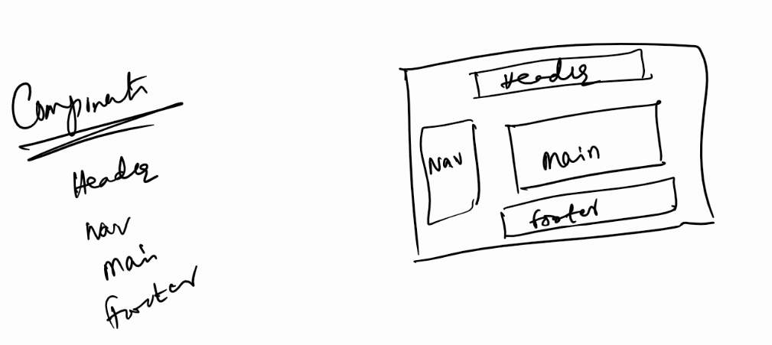

Angular CLI Installation

We should have node & npm installed already, because you will install angular cli using npm.

>> npm install -g @angular/cli

Note: Angular CLI is a one time installation, it gives you a command called ‘ng’ using which you can create angular applications & also run angular applications

After installing you can use ng --version

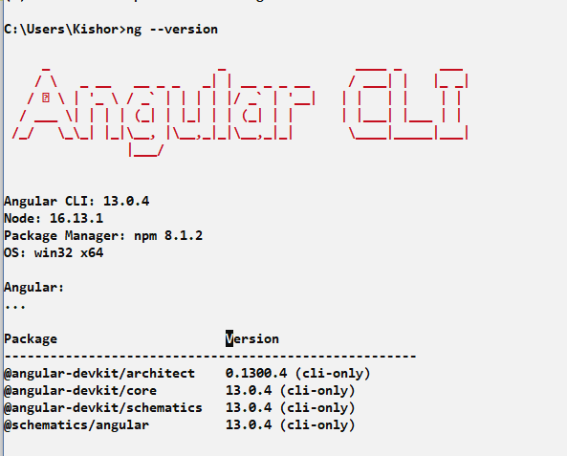

Command used to create angular project

>> ng new project-name

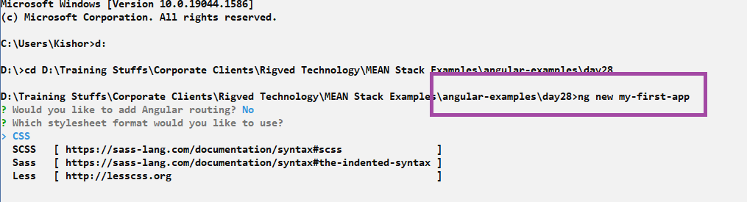

Once you install you will get the success confirmation

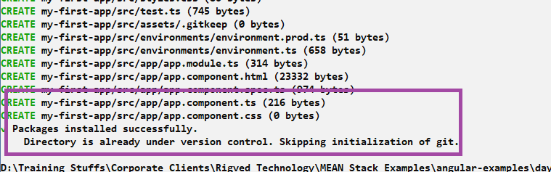

Purpose of *ng new <<app-name>>*

ng is an angular command

new is a keyword to create a new project

<<app-name>> must be the project name

Navigate to the project & use ng serve to run your project

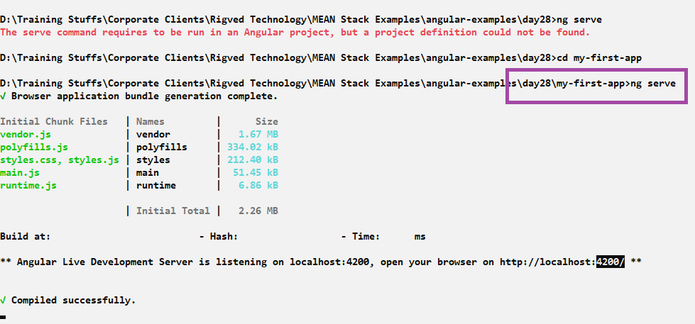

By default the project runs in 4200, which you can enter in the browser and by default every new project will have some default content which can be changed by adding UI’s in angular application according to your requirement.

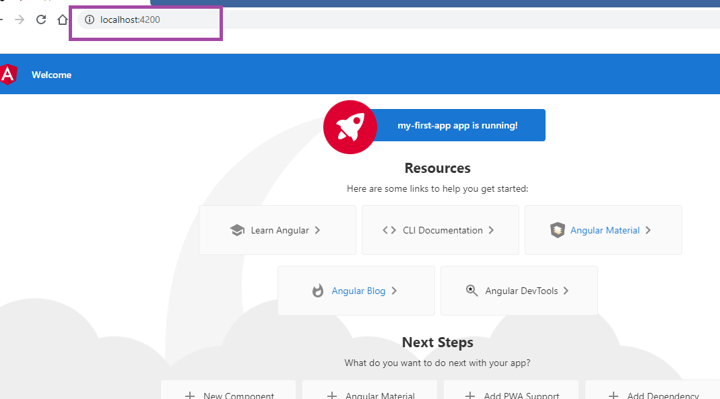

You can open angular project folder from the VS Code

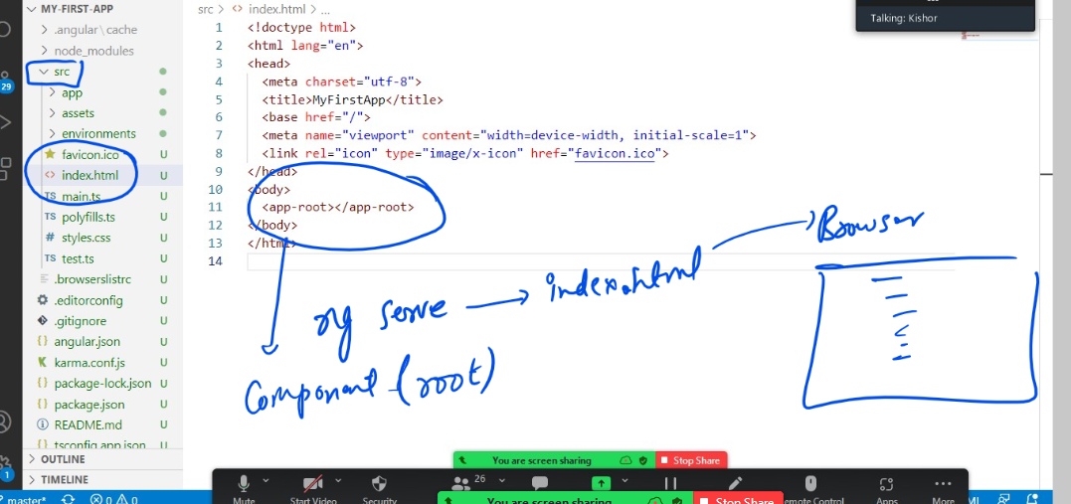

The moment you enter ng serve, angular loads index.html in the browser, that is only file which is loaded in the browser, but everything happens inside the index.html <app-root>, which is a root component, this root component can nest any number of components

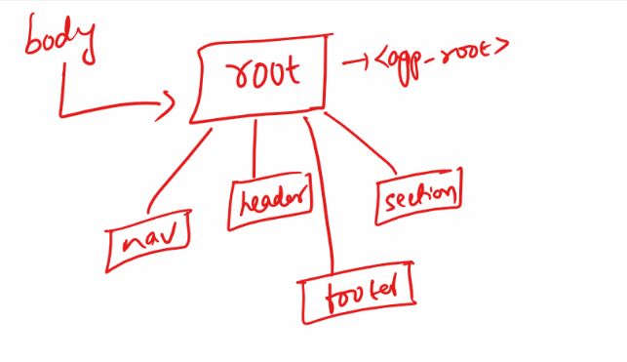

Every angular application must have one root component and it be only one root component all the other components are part of this root component.

<app-root>: This is the tag name for root component, when you use this tag the content of root component is displayed

Where’s the content of this <app-root>

src/app/app.component.html: This file has the content for <app-root>

How does angular knows <app-root> content is in app.component.html

It is mentioned in the src/app/app.component.ts

Two important files to know

app.component.html: It has root component content

app.component.ts: It has @Component({}) decorator which specifies the tag name for the root component and content for the tag

i.e., @Component({selector:’app-root’, templateUrl:’./app.component.html’})

@Component: It is a decorator which must written on top of the class when you want the class to behave like a UI component

Currently src/app/app.component.ts has below code not changed

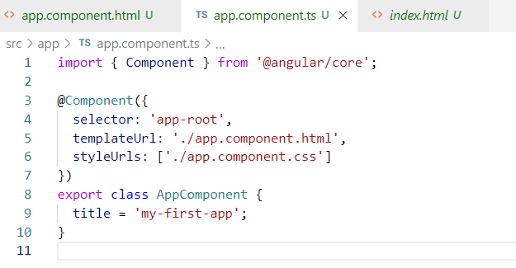

Modify the src/app/app.component.html to have a simple content

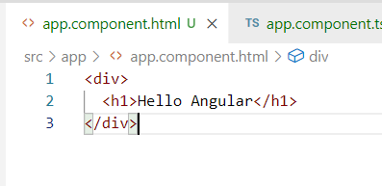

Angular can detect the changes and reload browser automatically

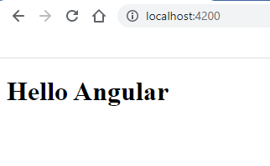

Note: The only file loaded in the browser is index.html & it must never be modified

Activity:

1. Try the above example as it is
2. Create a new project with the name my-second-app inside day28 folder and remove everything of src/app.component.html and add {{title}}